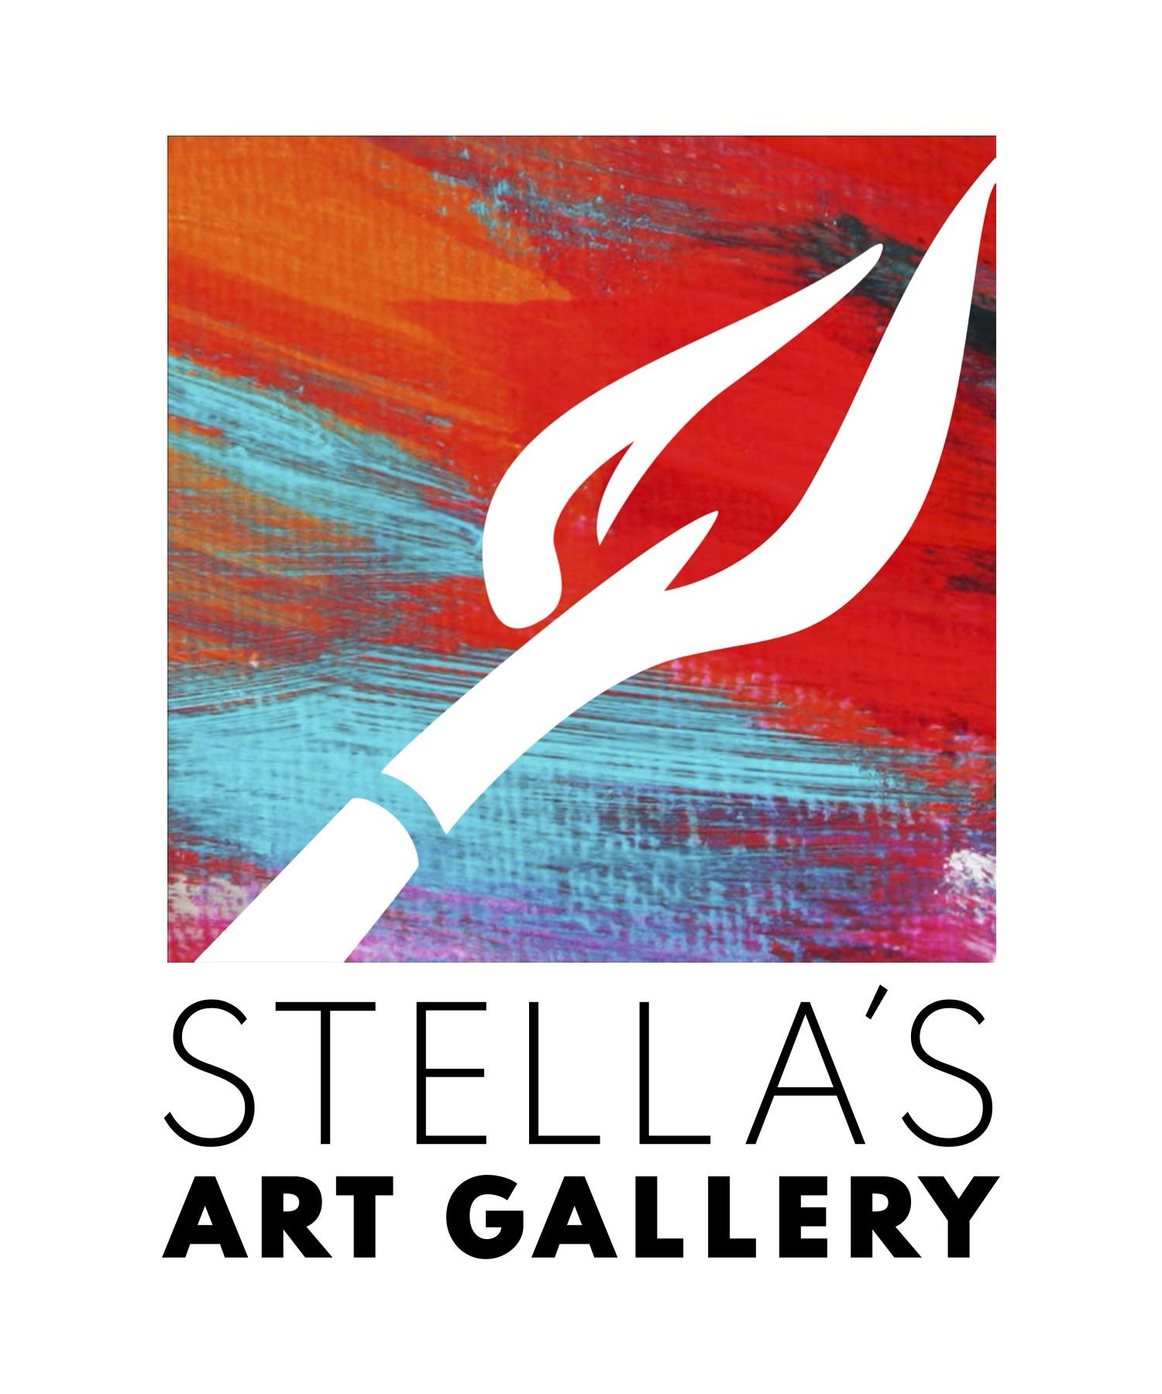
Functional Art
Functional Art refers to aesthetic objects that serve utilitarian purposes. Functional art is generally applied art - art created for use, designed to serve a purpose with an aesthetic in mind. The genre is remarkably inclusive: it encompasses everything from furniture and lighting to dishes, books and game design.

Stella’s Art Gallery
38033 Euclid Avenue
Willoughby, Ohio 44094
440-266-9111

Artist Name_________________________________________________
Address___________________________________________________________________________________________________________________________________
Phone_____________________________________
Email______________________________________

This is a juried show with Cash prizes and ribbons.
All Mediums Welcome
Drop off Dates: May 2nd & 3rd 11:30-7:30pm, May 4th 11:30-5:30
Fees to enter: 1 for $15, 2 for $20, 3 for $30, 4 for $40, 5 For $50
Categories:
Furniture (desks, tables, lamps, clocks etc)
Fabric (quilts, tapestries, blankets, etc)
Ceramics, Glass, Wood: (vases, dishes, platters, bowls etc)
Books, Paper, Game Design: (books, cards, handmade paper, board games etc)
Wearables: (clothes, jewelry etc)
Notification of acceptance will be the evening of May 6th. Unaccepted work must be collected on May 7th 11-6pm. Art will be picked up after the run of the show June 3rd 1-6pm. Reception: May 10th 7-9pm Awards promptly at 8:00.
I Hereby grant permission for my art work to be displayed at Stella’s Art Gallery May 10th-June 3rd. I personally assume responsibility for my art work and release Stella’s Art Gallery and it’s employees from loss or damage to my property. Stella’s Art Gallery will take 30% commission on any sold artwork during the run of the show. All artwork must have been created in the last 5 years, not shown in a Stella’s Art Gallery Show before, and ready to be displayed.

Artist Signature:_____________________________________________________________

Date:_______________________________
Note to artist about TAGS:
Use both sets of provided tags and please print your information. Tag each entry on the front of your artwork when possible and submit the other set of tags with application.
Questions: email Dani Klein at StellasArts@gmail.com
______________________________________________

INTAKE CHECK SHEET (OFFICE ONLY):
Application Form Compete:___________________
Tags: ____________________________________
Wired on Back:_____________________________
Condition: Please note any markings, scatches, and Imperfections on the frame and art: ____________________________________________________________________________________________________________________________________________________________________________________________________________________________________

Office Signature: ______________________________________________________________

Artist  __________________ | Artist  __________________ | Artist  __________________
Medium  __________________ | Medium  __________________ | Medium  __________________
Title  __________________ | Title  __________________ | Title  __________________
Price  __________________ | Price  __________________ | Price  __________________
Category  __________________ | Category  __________________ | Category  __________________

Artist  __________________ | Artist  __________________ | Artist  __________________
Medium  __________________ | Medium  __________________ | Medium  __________________
Title  __________________ | Title  __________________ | Title  __________________
Price  __________________ | Price  __________________ | Price  __________________
Category  __________________ | Category  __________________ | Category  __________________

